Supply Chain Management (SCM)
Week 8 · Session 5: SC Network Design — LP Optimization & Final Comparison
1. Recap — Same Problem, Better Method
- Same SC network as Session 4: 2 Manufacturers, 3 Warehouses, 4 Retailers, 1 product
- An ABC company has two manufacturing facilities m1 and m2.
- Company manufactures single product and distribute the product from three warehouses to four retailers.
- Manufacturer m1 has manufacturing capacity of 1,50,000 units and m2 has capacity of 1,20,000 units.
- Both the manufacturing facilities have the same production costs.
- All of three warehouses have same handling costs.
- Retailers have demands of 45000, 35000, 68000, 70000.

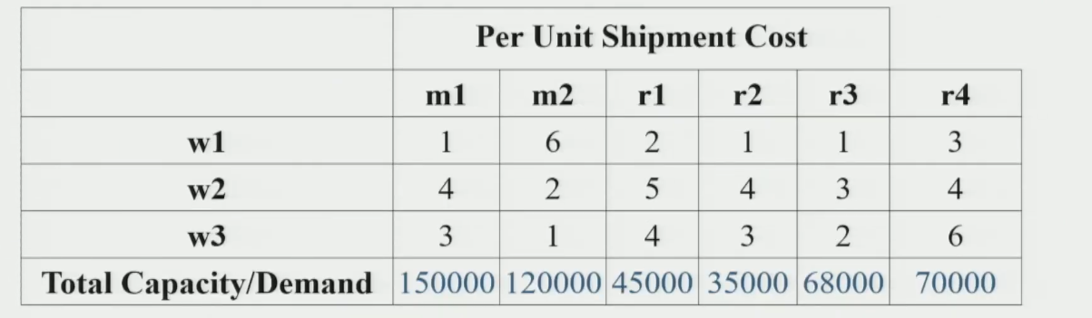
- Objectives:
- Find optimal distribution strategy that specifies the flow of products from manufacturer through warehouses to retailers
- To satisfy retailer's demand
- Minimize the total distribution costs.
- Session 4: solved using Heuristic 1 (₹9,61,000) and Heuristic 2 (₹7,57,000)
- This session: solve using Linear Programming (LP) + Excel Solver to get the true optimal
★ Heuristics give good solutions fast. LP gives the BEST solution. This session proves LP beats both heuristics.
2. LP Formulation — SC Network Design
Decision Variables — 18 total
- 6 variables: quantity moved between each Manufacturer–Warehouse pair (M→W tier)
- 12 variables: quantity moved between each Warehouse–Retailer pair (W→R tier)
- All initialized to 0 in Excel — Solver finds the optimal values

Variable | Meaning (Mfr → Warehouse tier)
Q_{M1W1} | Qty from Manufacturer 1 → Warehouse 1
Q_{M1W2} | Qty from Manufacturer 1 → Warehouse 2
Q_{M1W3} | Qty from Manufacturer 1 → Warehouse 3
Q_{M2W1} | Qty from Manufacturer 2 → Warehouse 1
Q_{M2W2} | Qty from Manufacturer 2 → Warehouse 2
Q_{M2W3} | Qty from Manufacturer 2 → Warehouse 3
Variable | Meaning (Warehouse → Retailer tier)
X_{W1R1} | Qty from W1→R1
X_{W1R2} | W1→R2
X_{W1R3} | W1→R3
X_{W1R4} | W1→R4
X_{W2R1} | W2→R1
X_{W2R2} | W2→R2
X_{W2R3} | W2→R3
X_{W2R4} | W2→R4
X_{W3R1} | W3→R1
X_{W3R2} | W3→R2
X_{W3R3} | W3→R3
X_{W3R4} | W3→R4

3. Objective Function
- Minimize total distribution cost = sum of (unit shipping cost × quantity) for all pairs
- In Excel: use SUMPRODUCT — multiplies each shipping cost with its corresponding decision variable and sums all

Minimize Z = Σ (Shipping Cost × Q__{MiWk}) + Σ (Shipping Cost × X__{WkRj})
[across all Mfr-WH pairs] [across all WH-Retailer pairs]

4. Constraints
- Three types of constraint — all must be satisfied simultaneously for a valid solution

Constraint Type | Expression | What it ensures
Supply (2 constraints) | Q_{M1W1}+Q_{M1W2}+Q_{M1W3} ≤ 1,50,000  Q_{M2W1}+Q_{M2W2}+Q_{M2W3} ≤ 1,20,000 | Total shipped from each Mfr ≤ its capacity
Flow Balance (3 constraints) | Σ(in to W1) = Σ(out of W1)  [repeat for W2, W3]  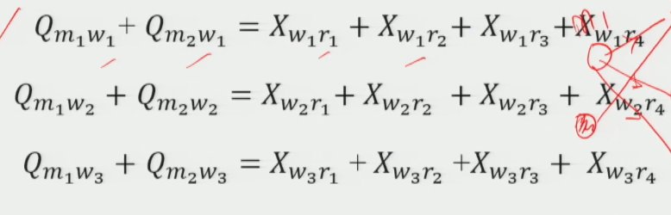 | What comes into a WH must go out — no stockpiling
Demand (4 constraints) | X_{W1Rj}+X_{W2Rj}+X_{W3Rj} = D_{j} for each j  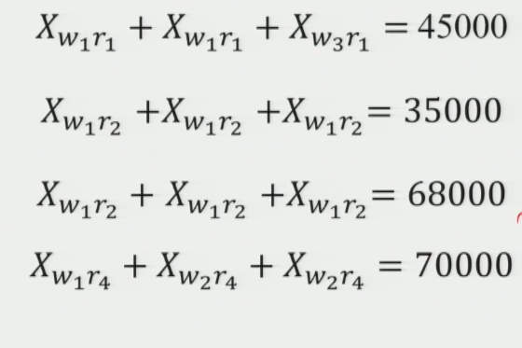 | All three WHs together must fully fulfill each retailer's demand
Non-negativity | All Q and X variables ≥ 0 | Quantities cannot be negative

Flow Balance Constraint — Key New Concept
- Ensures warehouses are pass-through nodes — they do not hold inventory
- Total units received by a WH must equal total units dispatched from that WH

For W1: Q_{M1W1} + Q_{M2W1} = X_{W1R1} + X_{W1R2} + X_{W1R3} + X_{W1R4}
For W2: Q_{M1W2} + Q_{M2W2} = X_{W2R1} + X_{W2R2} + X_{W2R3} + X_{W2R4}
For W3: Q_{M1W3} + Q_{M2W3} = X_{W3R1} + X_{W3R2} + X_{W3R3} + X_{W3R4}

★ Flow Balance is unique to multi-tier networks. Not present in single-tier Demand Allocation or CPLP. Learn to write it.

5. Solving in Excel — Step-by-Step

1 | Set Objective  Select the Total Cost cell → choose Minimize
2 | Changing Variable Cells  Select ALL decision variable cells (Q and X variables — 6 + 12 = 18 cells)
3 | Add Constraints  Use Add button: enter LHS cell, inequality sign, RHS value — repeat for supply, flow balance, and demand constraints
4 | Non-negativity  Check 'Make unconstrained variables non-negative'
5 | Solving Method  Select Simplex LP — model is fully linear (no binary variables, no square roots)
6 | Solve  Click Solve → message: 'All constraints and optimality conditions satisfied' → Keep Solver Solution
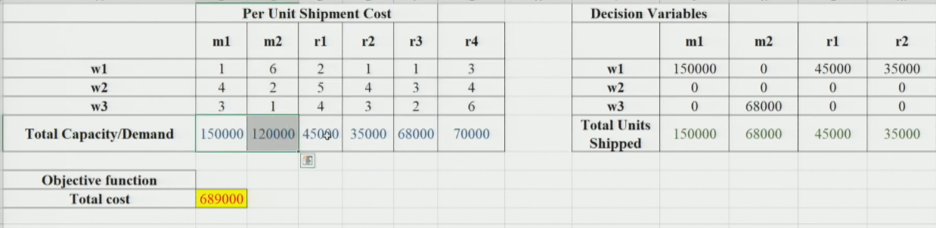
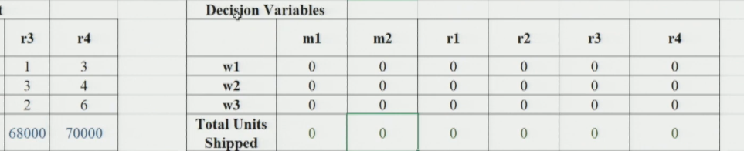
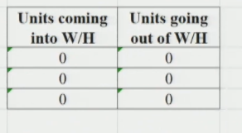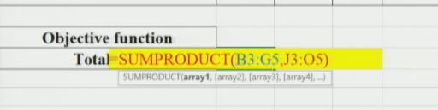
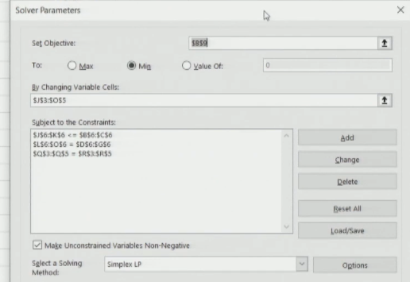
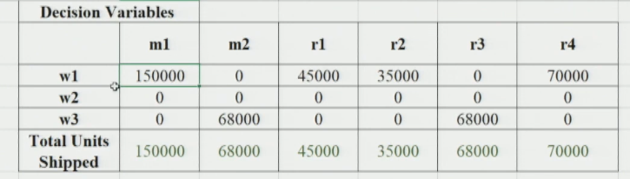

Installing Solver (if not visible)
- File → Options → Add-ins → Manage Excel Add-ins → Go
- Check Solver Add-in → OK → Solver will appear under Data tab

6. Result & Final Comparison
LP Optimal Solution
- Solver confirms: all constraints and optimality conditions satisfied
- Output: exact quantity to move on each Mfr→WH and WH→Retailer arc
- Total Distribution Cost = ₹6,89,000 ← global optimum

Approach | Heuristic 1 | Heuristic 2 | LP Optimization
Method | Cheapest WH for all | Cheapest path per retailer | Simplex LP via Excel Solver
Total Cost | ₹9,61,000 | ₹7,57,000 | ₹6,89,000
Optimal? | No | No | Yes — guaranteed
Savings vs H1 | — | ₹2,04,000 | ₹2,72,000

- LP beats H2 by ₹68,000 (~9%) — significant for a real-scale SC
- LP beats H1 by ₹2,72,000 (~28%)

★ The LP solution is guaranteed optimal — no other feasible distribution can cost less. This is the power of optimization.

7. Scalability & Practical Relevance
- This example: 2 Mfr + 3 WH + 4 Retailers = 18 decision variables — manageable manually
- Real SC: hundreds of facilities → thousands of variables → LP Solver still works
- Same formulation logic scales: add more nodes, the constraints grow, but the approach is identical
- Industries using this: FMCG, e-commerce, pharma, auto — any distribution-heavy sector

Session Summary
- Problem: 2 Mfr → 3 WH → 4 Retailers, minimize total shipping cost subject to supply & demand constraints
- Decision Variables: 6 (Mfr→WH) + 12 (WH→Retailer) = 18 total
- Objective: Minimize Σ(cost × quantity) — use SUMPRODUCT in Excel
- 3 Constraints: Supply (≤ capacity) | Flow Balance (in = out at WH) | Demand (= retailer requirement)
- Solver: Simplex LP — non-negativity checked — all constraints entered → solve
- Result: H1 = ₹9,61,000 | H2 = ₹7,57,000 | LP = ₹6,89,000 (optimal)

★ Exam Tip: Flow Balance constraint: Σ(into WH) = Σ(out of WH). This is unique to 2-tier networks. Know how to write it for each warehouse.
★ Exam Tip: Total decision variables = (no. of Mfr × no. of WH) + (no. of WH × no. of Retailers). For 2×3×4: 6+12=18.
★ Exam Tip: Solver method = Simplex LP (linear, no binary). Confirm optimality when solver says 'all constraints and optimality conditions satisfied'.
★ Exam Tip: LP always gives ≤ cost of any heuristic. Heuristics are feasible but sub-optimal. LP = global minimum.

